**Custom Text Styler with Toast Notification in Android**

**EXP NO: 10**

**Date:2.5.25**

# AIM:

Develop an application to change the font and color of the text and display toast message when the user presses the button.

# CODE:

**MainActivity.kt**

package com.example.myapplication_bijlesh

import android.graphics.Color import android.os.Bundle import android.widget.Button

import android.widget.TextView import android.widget.Toast

import androidx.activity.enableEdgeToEdge

import androidx.appcompat.app.AppCompatActivity import androidx.core.view.ViewCompat

import androidx.core.view.WindowInsetsCompat

class MainActivity : AppCompatActivity() {

override fun onCreate(savedInstanceState: Bundle?) { super.onCreate(savedInstanceState) enableEdgeToEdge() setContentView(R.layout.activity_main)

var txt:TextView=findViewById(R.id.textView) var btn:Button=findViewById(R.id.button)

var count=0 btn.setOnClickListener {

count++ txt.text=count.toString() txt.setTextColor(Color.RED)

txt.setBackgroundColor(Color.BLACK)

Toast.makeText(this,"Color Change and font",Toast.LENGTH_LONG).show() txt.textSize=18f

}

}

}

# activity_main.xml

<?xml version="1.0" encoding="utf-8"?>

<androidx.constraintlayout.widget.ConstraintLayout xmlns:android="<http://schemas.android.com/apk/res/android>"

xmlns:app="<http://schemas.android.com/apk/res-auto>" xmlns:tools="<http://schemas.android.com/tools>"

android:id="@+id/main" android:layout_width="match_parent" android:layout_height="match_parent" tools:context=".MainActivity">

<TextView android:id="@+id/textView" android:layout_width="wrap_content"

android:layout_height="wrap_content" android:text="Hello World!" app:layout_constraintBottom_toBottomOf="parent" app:layout_constraintEnd_toEndOf="parent" app:layout_constraintHorizontal_bias="0.461" app:layout_constraintStart_toStartOf="parent" app:layout_constraintTop_toTopOf="parent" app:layout_constraintVertical_bias="0.186" />

<Button

android:id="@+id/button" android:layout_width="wrap_content" android:layout_height="wrap_content" android:layout_marginTop="172dp" android:text="Count" app:layout_constraintEnd_toEndOf="@+id/textView" app:layout_constraintHorizontal_bias="0.0" app:layout_constraintStart_toStartOf="@+id/textView"

app:layout_constraintTop_toBottomOf="@+id/textView" />

</androidx.constraintlayout.widget.ConstraintLayout>

# OUTPUT:

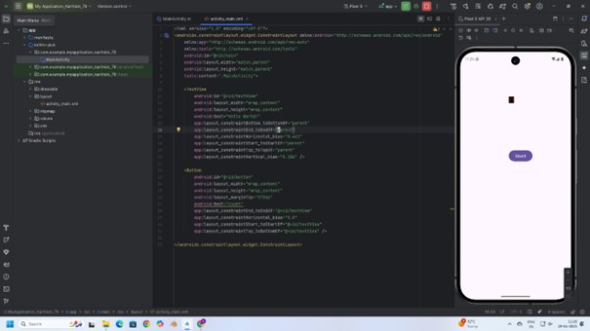

**RESULT:**

Thus, text customization and user interaction were successfully implemented by changing font and color, and displaying a Toast message on button click in the application.